Data Structures & Algorithms (CSC-214) Semester: Spring 2025
Instructor: Hamna Anwar Date: 28th Mar 2025
Lab 7: Doubly Linked Lists

Practice Lab 7:

Instructions: Download the given doubly linked list code, with individual characters stored in the nodes, attempt the following questions.

- Add a print function so you can test your code
- Add a findSequence function to the DLinkedList class which takes a string as an argument and indicates (return true/false) whether the sequence (in either direction) of the string/array/pointer is found in the linked list.

Confirm that your code is correct by implementing the following test case
Step 1: Create a list L, A, S, T, M, A, X, E
Step 2: Search for the following strings:
String | Return value of the findSequence function
Find LAST | True
Find EXAM | True
Find MAX | True
Find MAZE | False

MUST GO THROUGH THE FOLLOWING MATERIAL BEFORE ATTEMPTING THE LAB
Strings are used for storing text. A string variable contains a collection of characters surrounded by double quotes. Strings are more convenient to use than character arrays (also called C-style arrays). The library, <string>, is required

- Simple string code:

string greeting = "Hello";
cout << greeting;
return 0;

Output:
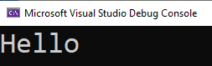

- Concatenation:

string firstname = "John";
string lastname = "Doe";
string fullname = firstname + " " + lastname;
cout << fullname;

Output:
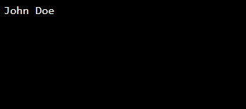

- Append:
More convenient than using a char array.

string firstname = "John ";
string lastname = "Doe";
string fullname = firstname.append(lastname);
cout << fullname;

Output:

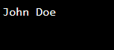

- Length

string text = "ABCDEFGHIJKLMNOPQRSTUVWXYZ";
cout << "The length of the text is: "<< text.length();

Output:

- Accessing Individual Characters

string text = "ABCDEFGHIJKLMNOPQRSTUVWXYZ";
cout << text[2];
Output:

- Changing Individual Characters

string text = "ABCDEFGHIJKLMNOPQRSTUVWXYZ";
text[2] = 'R';
cout << text;

Output:

- Problem with cin

string fullname;
cout << "Type your fullname: ";
cin >> fullname;
cout << "Here is your entered information: " << fullname;

Output:
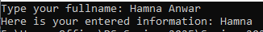

- Alternative to cin

string fullname;
cout << "Type your fullname: ";
getline(cin, fullname);
cout << "Here is your entered information: " << fullname;

Output:

- Alternative use
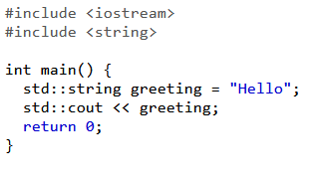

Output:
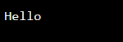

- Check if strings are equal

string a = "hello";
string b = "world";
string c = "hello";

if (a == c)
cout << "A is equal to C ";

Output:
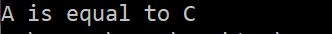

- Substrings

string str = "We think in generalities, but we live in details";
string str2 = str.substr(3, 5); //3 is the index, 5 is the length
int pos = str.find("live"); //returns index of the first character
string str3 = str.substr(pos); //from pos till end of sentence
cout << str2 << " " << str3 << endl;

Output:

